**Computing Trends**

The first computers were MainFrame Computers.

* Process Massive Data.
* Multiple users.

Personal Computers: IBM PC

Mobile Computing:

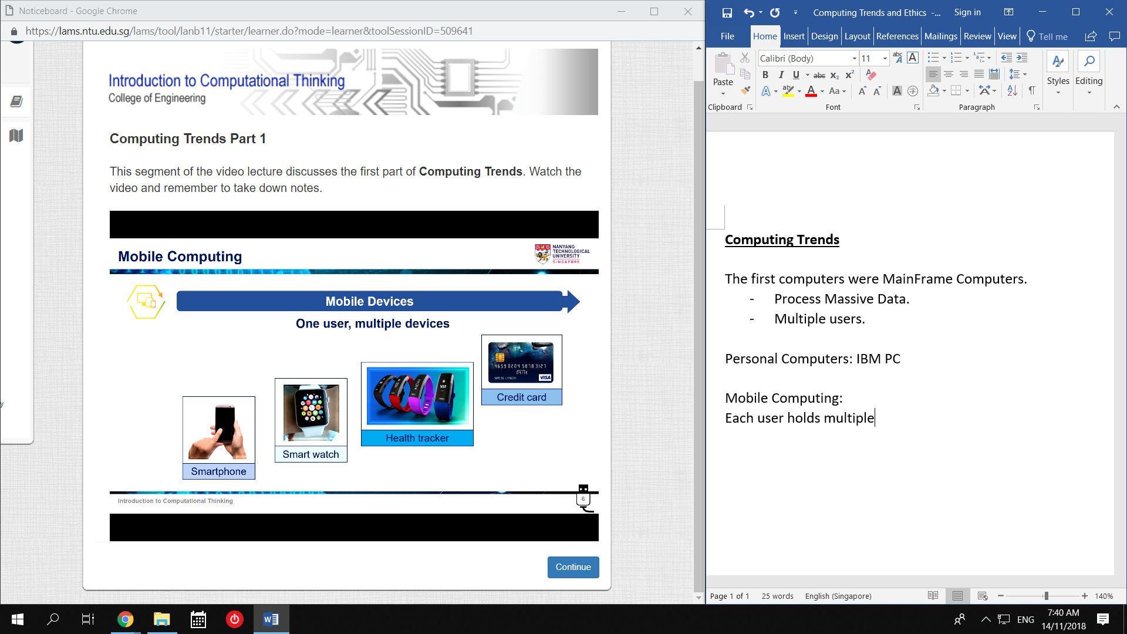

Each user holds multiple smart devices.

Microprocessors are ubiquitous.

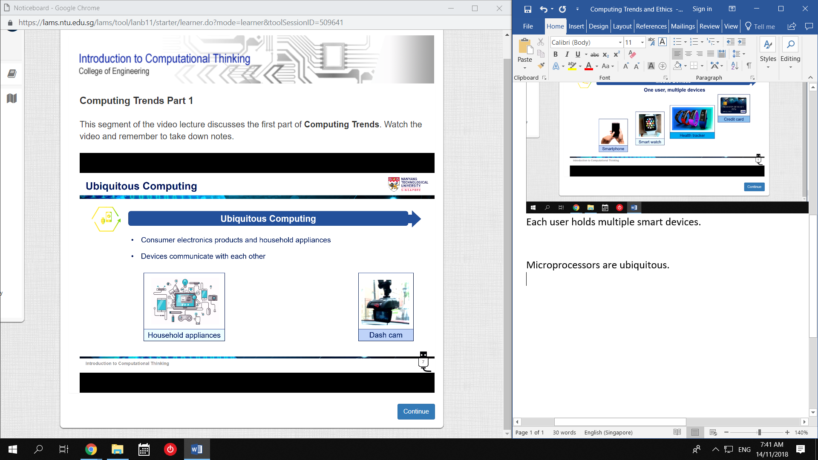

They can communicate with each other.

* Minimizes user input. Makes things easier.

Internet of Things

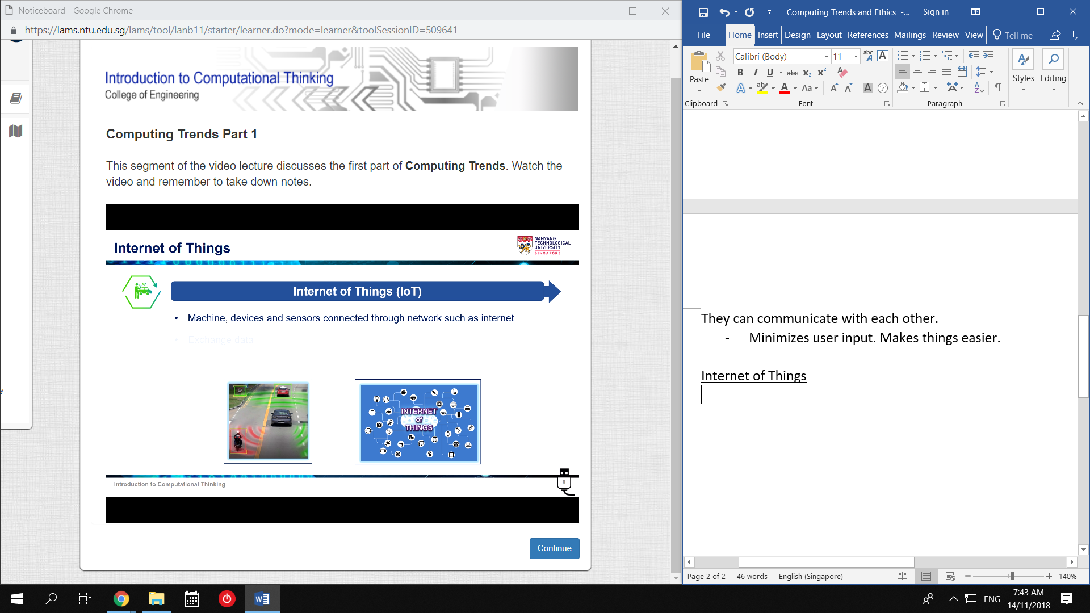

Devices can exchange data through connected networks.

* Efficient

Cloud Computing

Data Centers contains Server computers.

* Devices can manage data.

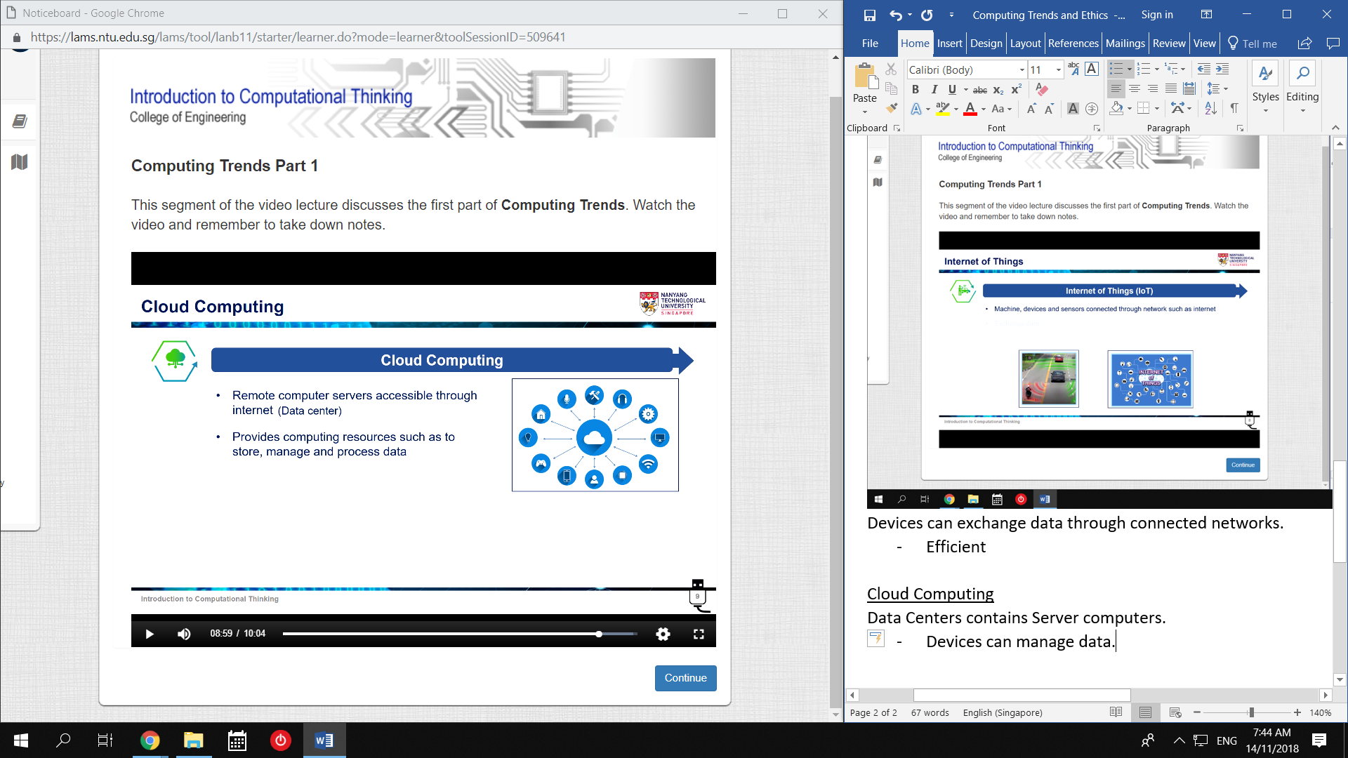

Cloud Computing: Computing services are provided by a third-party.

* Users can focus on development

Data Centre

Collection of Server Machines at a location

* Provides Computing Resources
* Large Data
* Also used to host Cloud Computing

Multiple Data Centres:

* Backup

Fog and Edge Computing

Cloud is not suitable for Time-Critical applications.

* Latency

Fog Computing:

* Data processing is at Network Layer

Edge Computing:

* Data is processes at Device Layer

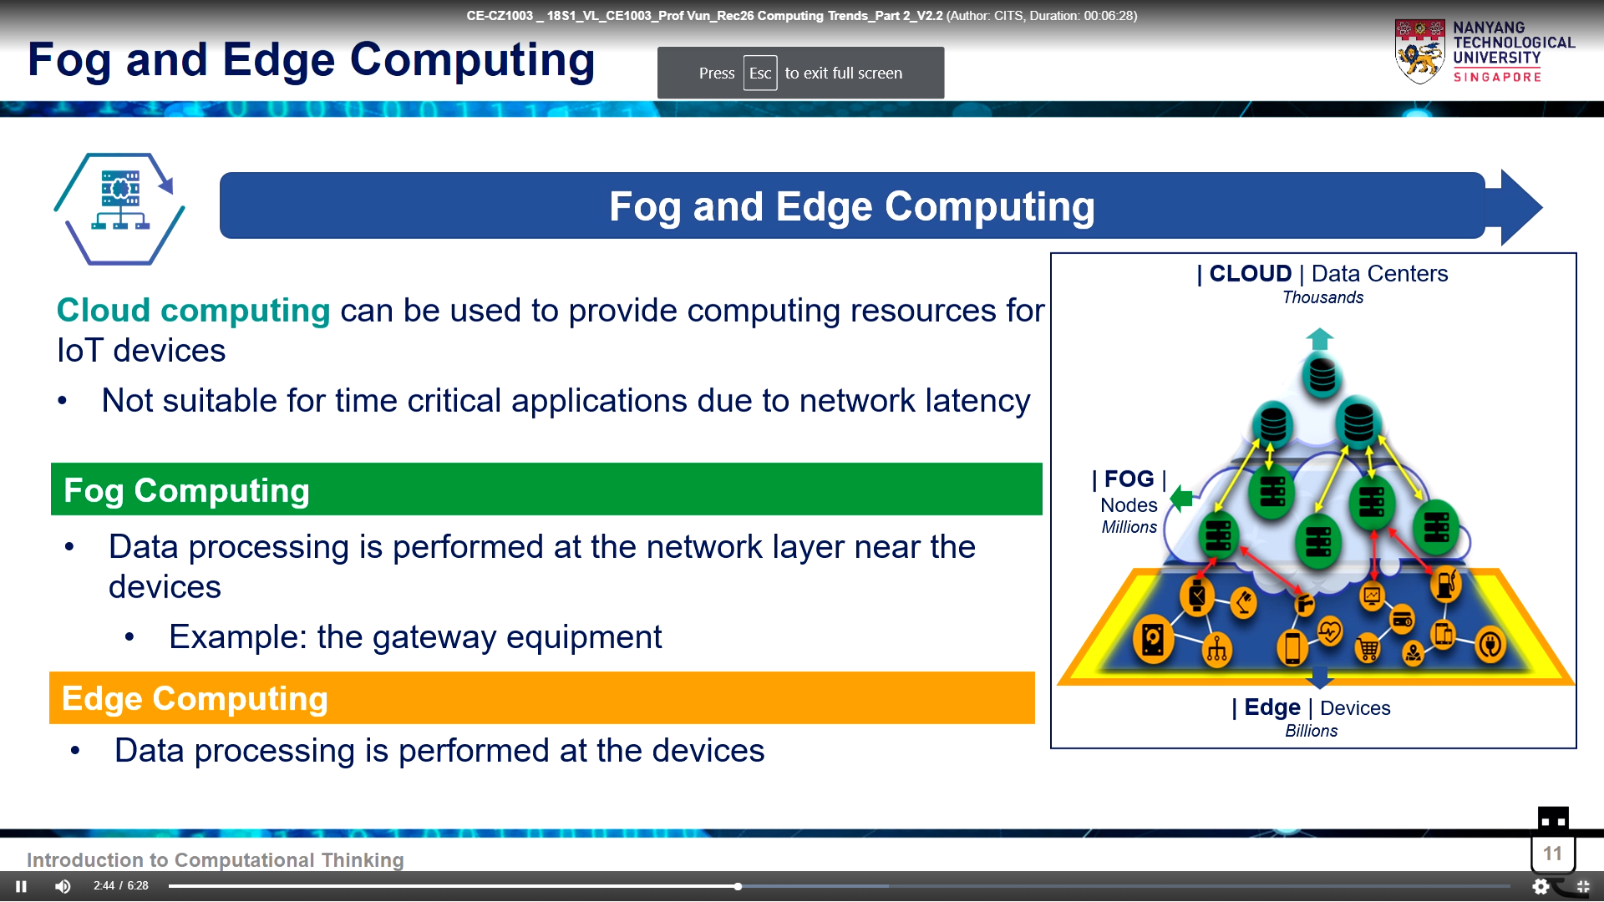

Augmented Reality and Virtual Reality

AR – Augment Real-world objects with computer info

VR – Simulate 3D environment

* These can enhance Learning and Services.

AI

Exhibit intelligence like a human.

Become better at the task

* Via Machine Learning Algorithms.

AI ideas are old.

Exponential Computing power, Fog/Edge Computing, have made it viable.

* Face Recognition
* Speech Recognition
* Recommendation Algorithms
* Self-Driving

**Computer Ethics**

1. Computers in Workplace

Computers don’t get tired.

Computers are far more efficient.

Therefore, Economic Incentive to replace humans is High.

* Includes Med and Law

Jobs not eliminated are radically altered.

* Pilot watches.
* Restaurants press buttons.

New jobs are created though.

* hardware engineers, software engineers, systems analysts, webmasters.

New altered Jobs too.

* Computer assisted Drafting
* Keyhole Surgery

2. Computer Crime

There are five aspects of software security.

1. Privacy

2. Integrity – Data cannot be modified without permissions

3. Unimpaired Service

4. Consistency – Data and Behaviour remain constant

5. Controlling access to resources

Some examples of things that break these:

* Viruses: Inserted into other programs
* Worms: Spread across networks
* Trojans: Pretend to be some other program
* Logic Bombs: Execute when Conditions arise
* Bacteria: Fill Memory

Normally, computer crimes are committed by trusted personnel with access.

Some hackers commit crimes.

Others spy on companies, or expose security risks. They say they are helpful to society.

* Still harmful, because the owner must do a thorough check to verify.

3. Privacy

In 1960, the US Govt. created large databases of citizen information and placed information under the citizen’s unique ID.

This was scrapped due to public outcry.

Computers can gather, process, and share personal information very efficiently.

In 1970, major computer privacy laws were passed.

However, several things have led to new privacy issues:

* Commercialization and Rapid Growth of the Internet
* Computer Processing Power
* Increased User Friendliness
* New Tech: Datamining, Datamatching, Click-Trail Records

[Tavani, 1999]

This has caused Philosophers to reexamine the concept of privacy.

Original: [Westin, Miller, Fried, Elgesem]

“Control over personal information.”

New: [Tavani, Moor]

“Restricted Access to others.”

New: [Nissenbaum]

“Privacy in public spaces, other than the intimate.”

This will likely continue. [Introna]

Anonymity

Good:

* Discussing sensitive topics (eg. politics, mental illness)
* Preserve security, peace of mind

Bad:

* Crimes (eg. Drug Trading, Terrorism)
* Preying on the Vulnerable

[Marx, Nissenbaum]

4. Intellectual Property

Some people believe all software should be free to:

* Copy
* Study
* Modify
* Richard Stallman, owner of Free Software Foundation.

Others argue that companies would not invest time and money otherwise.

* Licensing fees, Sales

The software industry is a Multibillion dollar industry.

* Some think ‘casual copying’ for friends should be allowed.
* Software companies claim ‘copying’ loses them Billions.

Ownership contains Four things:

1. Source Code

2. Object Code (machine-language)

3. Algorithm (commands given to machine)

4. Look and Feel (UI)

Owning an Algorithm is controversial.

* The Mathematical Formula used can be denied to others.
* Mathematicians claim this can cripple Science.
* Running a ‘Patent Search’ to check for plagarism is Costly.
* Big Companies can afford to. Small companies cannot.
* This stifles Competition and Program Variety.

5. Professional Responsibility

Computer Professionals have relationships with many levels of Society.

Employer – Employee

Other Professionals

Clients

Society

A Responsible Computer Professional should try to avoid Conflict of Interest.

Some Professional Organizations have established Codes of Ethics.

Eg. (ACM, IEEE)

ACM code (1992) includes:

* Avoid Harm to others
* be Honest and Trustworthy
* Acquire and Maintain Competence
* Know and Respect Existing Laws
* General Moral Imperitives

IEEE Code (1990) includes:

* Avoid Conflict of Interest
* Be Realistic in stating Claims or Estimates based on available Data

It is clear that professional organizations recognize and insist on Standards of Professional Responsibility.

6. Globalization

Ethics is important globally.

As it grows, we can call it: “Global Information Ethics.”

The Ethics Paper

“The Computer Revolution and the Problem of Global Ethics.” [Krystyna Gorniak-Kocikowska]

It details that:

* Ethics and Values will be Debated in a Global Context.
* Not Constrained by Region, Religion, or Culture.

This includes:

1. Laws

- Crimes committed in Country A. Can/Cannot be Tried in Country B?

2. Cyberbusiness

- When Transactions are 100% Secure and Private, Cyberbusinesses will explode.

- Will this cause Political/Socioeconomic Issues?

3. Education

- Inexpensive access to global information is available.

- How will this affect Dictatorships, Isolated communities, Cultures, Religion?

- Will Lesser Universities go out of business?

4. Rich-Poor Information Gap

- Education, Business, and Employment are moving into Cyberspace.

- Will Opportunities and Necessities of life become restricted for the Poor?